Balloon X Cumbria Project
MINUTES OF 1 JUNE 2020 & AGENDA FOR 8 JUNE 2020
MEETING NO. 1 : MINUTES
Date & time of meeting |  | 1 June 2020 | Actions
Attendees (delete as appropriate) |  | Jonathan Moore  Joe Moore  Jack Scott  Natasha Stannett  Poppy Watson  Penny Watson
Minutes
1 | Chairperson  Minute Taker | Jonathan
2 | Approval of minutes from the last meeting | N/A
3. | Project Agenda Items:  - Jonathan introduced the project. A summary document would be circulated later;  - Jonathan explained what Crest Gold was and how it would be achieved with a combination of a project report and a personal profile. It is externally assessed by the assessor reviewing the work and with a 15 minute interview of each candidate. Details of Crest Gold has been circulated. Rachel would take an action to register the project;  - Jonathan and Penny explained how the project would progress with social distancing initial and then (hopefully) with workshops;  - Penny explained about the blog and Poppy and the team took an action to introduce and register for the blog;  - Jonathan outlined the likely 12 week timetable for the project. It is hoped to launch before the start of next school term;  - Jonathan asked the team to consider outreach opportunities and report back;  - The following assignments were allocated and the team took an action to provide written work (e.g. half a page) on the blog on the following topics by the next meeting:  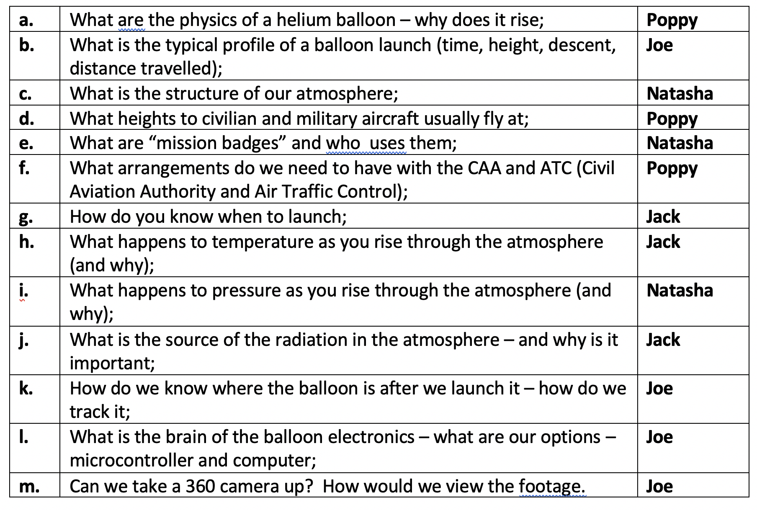 |  | Jonathan  Rachel  Poppy  ALL
5. | Next meeting: | Monday 8 June 6pm Zoom

MEETING NO. 2 : AGENDA

Date & time of next meeting |  | 6pm 8 June 2020
Agenda
1 | Chairperson  Minute Taker | Poppy Watson  tbc
2 | Approval of minutes from the last meeting | Confirm all have read as accurate  Go through & report back on actions  Approve
3. | Project Agenda Items:  - Guided tour of the blog site – Penny/Poppy;  - Team members to report on their initial research assignments – all team members (just a summary);  - Crest Gold update – Rachel;  - Detailed overview of project – Jonathan  - Proposal for a quick outside “socially distanced” get together at Beech Hill to introduce the payload, antenna, electronics etc – Jonathan and all;  - “Learning to solder” kit – Jonathan;  - Data protection – Jonathan;  - Community and school liaison – Penny;  - Assignment of initial roles (which may be rotated, shared etc):  - Flight operations directors - FOD;  - CAA/ATC - FAO;  - Programming - GNC;  - Electronics build and test and onboard images - EECOM;  - Balloon / parachute size and fill – FIDO;  - Radio and tracking - TELMU;  - Recovery team - PDRS;  - External images and video - PENNY;  - Community and school liaison - PAO;  - Launch day reporting - PAO;  - Further research assignments:  - How do you send a digital signal over an analogue transmitter;  - What is a “radar reflector” and how does it work, Why do we need one;  - Do we need to “heat” the payload internally?  - Checklists checklists checklists;  - How is a balloon rigged – payload, parachute, balloon;  - How do we know when we have filled the balloon with enough helium;
4. | Any other business
5. | Next meeting:  - Date & time  - Agenda items  - Chairperson  - Minute taker

